hHelp

1. Think Positive!
2. Discuss the test openly and in a positive way.
3. Have realistic expectations of your child's performance while encouraging his/her best efforts.
4. Emphasize that the test is only one measure of academic performance.
5. Ensure your child is well rested, eats a healthy breakfast and arrives on time.
6. Follow up and review test scores with your child and their teacher and school counselor

# E-School and Curriculum

**There was a recent upgrade to the e-school system and as a result passwords and usernames are all case sensitive now.** If you are having trouble logging in, try using all lower case letters. If the system has locked you out, wait two hours for it to reset. If you need assistance, contact central registration or the e-school support.

Home Access Help Desk: 435-4505 or

[*homeaccess@scsd.us*](mailto:homeaccess@scsd.us)*.*

Homework, Homework, Homework!!

Help your child succeed by checking their **planner** daily to make sure they have written down their homework. Make homework time a part of their routine at home. Students are expected to read and log for at least 30 minutes every night! Check out this informational website that includes a parent’s back pack guide to the new

**Common Core Curriculum**:

[http://www.engageny.org/parent-and-family-resources](https://webmail7.scsd.us/owa/redir.aspx?C=HJoTRCLb9kOb20z0BeJdldZHSp1sntBIvm39_5LYdS14S1YghsxuL2iJBT-0ZhDcqWyS7FafjSQ.&URL=http%3a%2f%2fwww.engageny.org%2fparent-and-family-resources)

Middle School Grading Policy

Homework = 20% Participation = 10

Tests = 40% Class work = 15% Quizzes = 15 %

# Test Prep: remember these key tips to help your child do their best

# College and Career Readiness

**J.T. Roberts Annual Career Fair** was **March 19th**

Over 30 career representatives met with our 7th and 8th grade students to help them learn about postsecondary options.

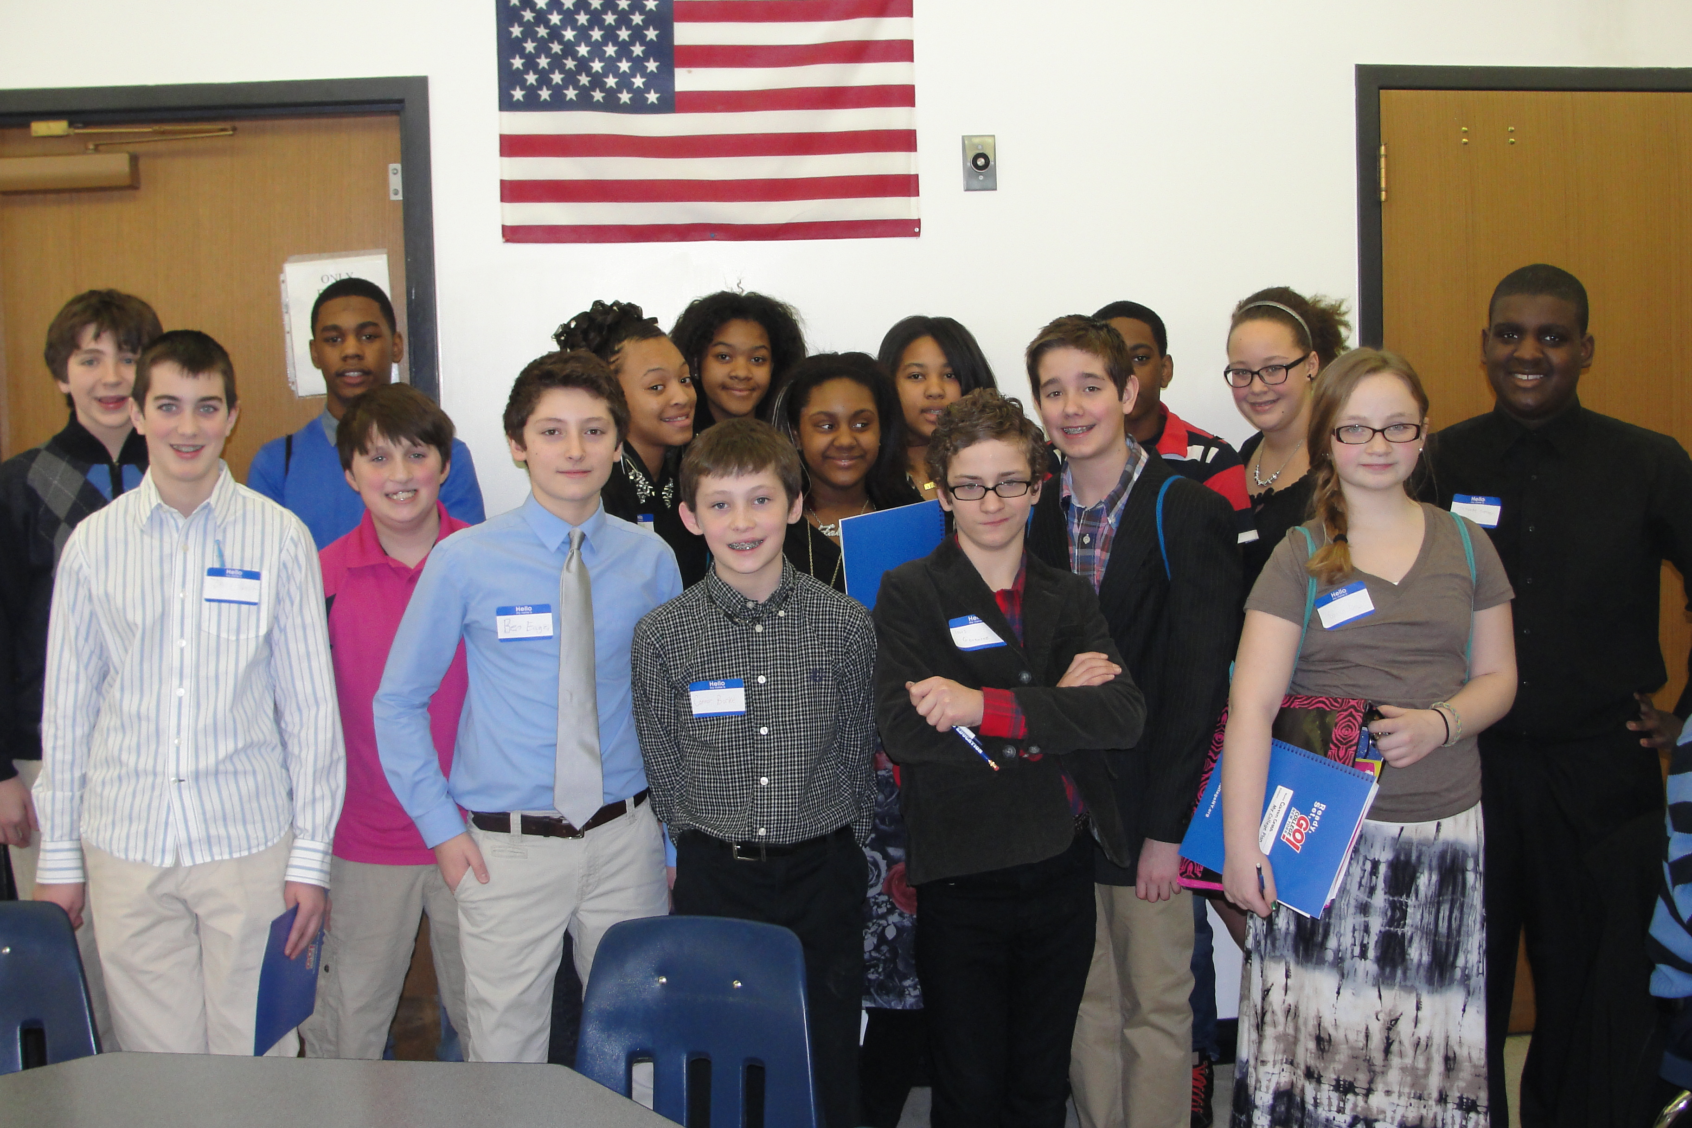

**Naviance News**

A web based career planning tool that Ms. Dunn uses with students in grades 6, 7 and 8 to help them with academic success and future planning. Here is what we have done so far:

Grade 6: Learning Styles Inventory and goal setting.

Grade 7: Career Cluster Finder (ask your child what their career category is). My Road Map-students can watch over 3000 interviews of people in various careers.

Grade 8: Career Key (ask your child what their career category is). Students also have completed a resume where they had to identify their character qualities, skills, awards, and extra curricula involvement to help them prepare for their future.

**More Classroom News: Art, Music & PE**

**Art-** Eighth grade art students each chose a work of art done by a famous artist. They are enlarging that art work to twice its size by using the GRID TECHNIQUE which incorporates mathematics into the lesson.  Once it is enlarged they are adding color with watercolor paint.  Seventh grade art students created an OP ART piece in tempera paint. Op Art is a style of abstract art organized in such a way as to create optical illusions of movement and to fool the viewer's sense of perspective. They have just begun work on portraiture. Sixth grade art students have started 1-POINT PERSPECTIVE. This is a technique artists use to create the illusion of 3D on a 2D surface. They are creating a landscape in 1-pt. perspective which will give them a foundation and prepare them for learning a more complicated 2-pt. perspective in seventh grade. **Music-** 6th graders are beginning their unit in the popular music of the 20th century, from Rag to Rap.

8th grade is currently learning about the Musical characteristics and composers of the major musical eras, from medieval to modern.

**Physical Education**- classes just finished the basketball unit for march madness. Next students will complete the pacer test. All modified spring sports for grades 7 and 8 have begun. The sports being offered are Boys & Girls Lacrosse, Boys & Girls Track, Softball and baseball.

Tips for Middle School Success

Julie Dunn

School Counselor

315-435-4836

Judunn97@scsd.us

***The Roberts School Vision***

*To cultivate inquiring, open-minded and caring young people with a strong foundation in academics, preparing them for high school, college and career success.*





